**⇒ Mandatory Hands-On**

**Exercise 1: Control Structures**

**Scenario 1:** The bank wants to apply a discount to loan interest rates for customers above 60 years old.

SET SERVEROUTPUT ON;

DECLARE

    CURSOR cust_cursor IS

        SELECT c.CustomerID, c.DOB, l.LoanID, l.InterestRate

        FROM Customers c

        JOIN Loans l ON c.CustomerID = l.CustomerID;

    v_CustomerID   Customers.CustomerID%TYPE;

    v_DOB          Customers.DOB%TYPE;

    v_LoanID       Loans.LoanID%TYPE;

    v_InterestRate Loans.InterestRate%TYPE;

    v_Age          NUMBER;

BEGIN

    FOR rec IN cust_cursor LOOP

        v_CustomerID   := rec.CustomerID;

        v_DOB          := rec.DOB;

        v_LoanID       := rec.LoanID;

        v_InterestRate := rec.InterestRate;

        v_Age := FLOOR(MONTHS_BETWEEN(SYSDATE, v_DOB) / 12);

        IF v_Age > 60 THEN

            UPDATE Loans

            SET InterestRate = v_InterestRate - 1

            WHERE LoanID = v_LoanID;

            DBMS_OUTPUT.PUT_LINE('✅ Discount applied | Customer ID: ' || v_CustomerID ||

                                 ' | Loan ID: ' || v_LoanID ||

                                 ' | Age: ' || v_Age ||

                                 ' | New Interest Rate: ' || TO_CHAR(v_InterestRate - 1));

        ELSE

            DBMS_OUTPUT.PUT_LINE('ℹ️ No discount | Customer ID: ' || v_CustomerID ||

                                 ' | Loan ID: ' || v_LoanID ||

                                 ' | Age: ' || v_Age);

        END IF;

    END LOOP;

    COMMIT;

END;

/

Result

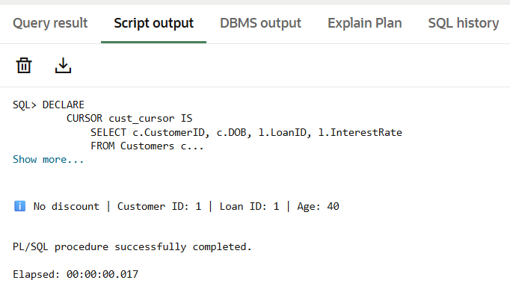

**Scenario 2:** A customer can be promoted to VIP status based on their balance.

ALTER TABLE Customers ADD IsVIP VARCHAR2(5);

SET SERVEROUTPUT ON;

DECLARE

    CURSOR cust_cursor IS

        SELECT CustomerID, Balance

        FROM Customers;

    v_CustomerID Customers.CustomerID%TYPE;

    v_Balance    Customers.Balance%TYPE;

BEGIN

    FOR rec IN cust_cursor LOOP

        v_CustomerID := rec.CustomerID;

        v_Balance    := rec.Balance;

        IF v_Balance > 10000 THEN

            UPDATE Customers

            SET IsVIP = 'TRUE'

            WHERE CustomerID = v_CustomerID;

            DBMS_OUTPUT.PUT_LINE('✅ Promoted to VIP | Customer ID: ' || v_CustomerID ||

                                 ' | Balance: ' || v_Balance);

        ELSE

            DBMS_OUTPUT.PUT_LINE('ℹ️ Not eligible for VIP | Customer ID: ' || v_CustomerID ||

                                 ' | Balance: ' || v_Balance);

        END IF;

    END LOOP;

    COMMIT;

END;

/

Result

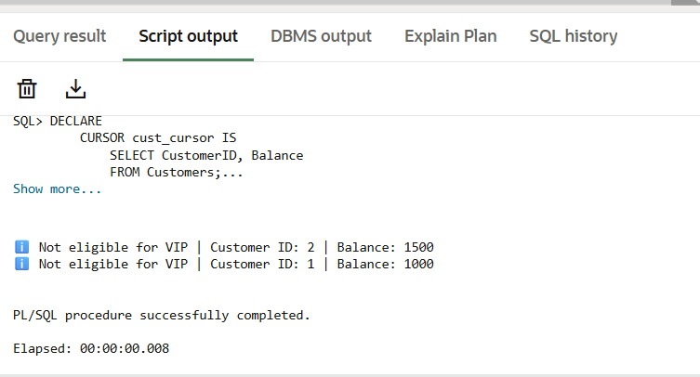

**Scenario 3:** The bank wants to send reminders to customers whose loans are due within the next 30 days.

SET SERVEROUTPUT ON;

UPDATE Loans

SET EndDate = SYSDATE + 10

WHERE LoanID = 1;

COMMIT;

DECLARE

    CURSOR due_loans IS

        SELECT l.LoanID, l.EndDate, c.CustomerID, c.Name

        FROM Loans l

        JOIN Customers c ON l.CustomerID = c.CustomerID

        WHERE l.EndDate BETWEEN SYSDATE AND SYSDATE + 30;

    v_LoanID     Loans.LoanID%TYPE;

    v_EndDate    Loans.EndDate%TYPE;

    v_CustomerID Customers.CustomerID%TYPE;

    v_Name       Customers.Name%TYPE;

    v_found BOOLEAN := FALSE;

BEGIN

    FOR rec IN due_loans LOOP

        v_found := TRUE;

        v_LoanID     := rec.LoanID;

        v_EndDate    := rec.EndDate;

        v_CustomerID := rec.CustomerID;

        v_Name       := rec.Name;

        DBMS_OUTPUT.PUT_LINE('📢 Reminder: Loan ' || v_LoanID ||

                             ' for customer ' || v_Name ||

                             ' (Customer ID: ' || v_CustomerID || ')' ||

                             ' is due on ' || TO_CHAR(v_EndDate, 'YYYY-MM-DD'));

    END LOOP;

    IF NOT v_found THEN

        DBMS_OUTPUT.PUT_LINE('ℹ️ No loans due in the next 30 days.');

    END IF;

END;

/

Result

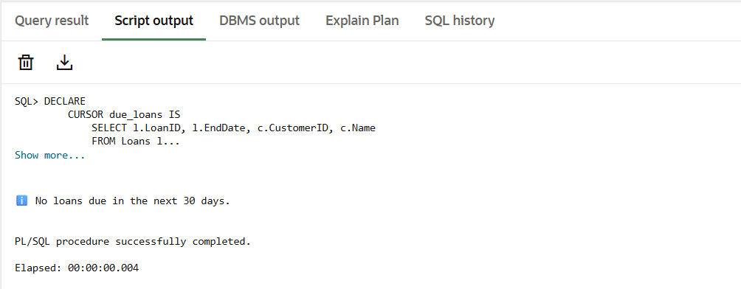

**Exercise 3: Stored Procedures**

**Scenario 1:** The bank needs to process monthly interest for all savings accounts.

CREATE OR REPLACE PROCEDURE ProcessMonthlyInterest AS

BEGIN

FOR acc IN (

SELECT AccountID, Balance

FROM Accounts

WHERE AccountType = 'Savings'

) LOOP

UPDATE Accounts

SET Balance = Balance + (Balance * 0.01)

WHERE AccountID = acc.AccountID;

DBMS_OUTPUT.PUT_LINE('Interest applied to Account ID: ' || acc.AccountID);

END LOOP;

COMMIT;

END;

/

SET SERVEROUTPUT ON;

BEGIN

ProcessMonthlyInterest;

END;

/

SELECT AccountID, AccountType, Balance FROM Accounts;

Result

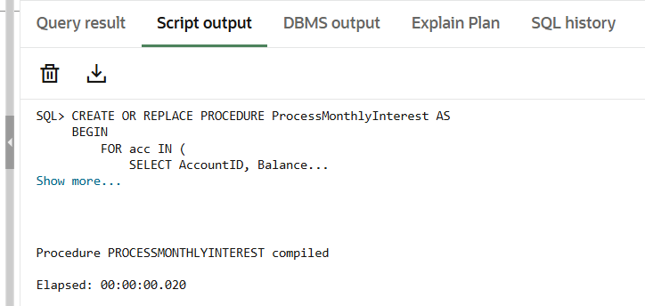

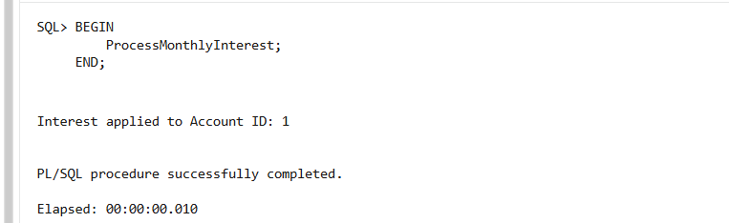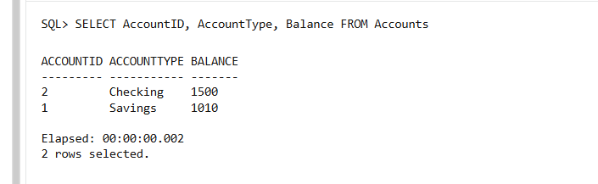

**Scenario 2:** The bank wants to implement a bonus scheme for employees based on their performance.

CREATE OR REPLACE PROCEDURE UpdateEmployeeBonus (

p_Department IN VARCHAR2,

p_BonusPercent IN NUMBER

) AS

BEGIN

FOR emp IN (

SELECT EmployeeID, Salary

FROM Employees

WHERE Department = p_Department

) LOOP

UPDATE Employees

SET Salary = Salary + (Salary * (p_BonusPercent / 100))

WHERE EmployeeID = emp.EmployeeID;

DBMS_OUTPUT.PUT_LINE('Bonus applied to Employee ID: ' || emp.EmployeeID);

END LOOP;

COMMIT;

END;

/

SET SERVEROUTPUT ON;

BEGIN

UpdateEmployeeBonus('IT', 10);

END;

/

SELECT EmployeeID, Name, Department, Salary FROM Employees;

Result

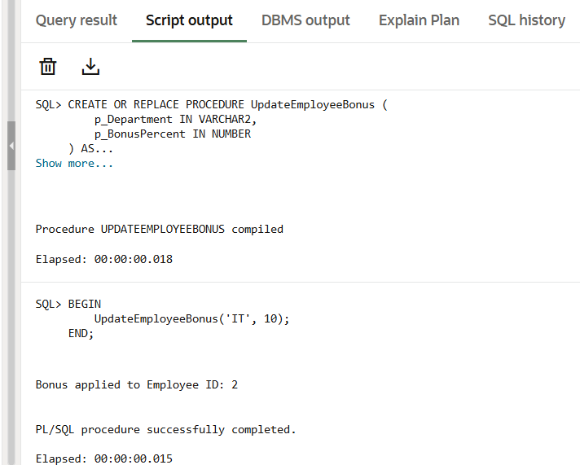

**Scenario 3:** Customers should be able to transfer funds between their accounts.

CREATE OR REPLACE PROCEDURE TransferFunds (

p_FromAccountID IN NUMBER,

p_ToAccountID IN NUMBER,

p_Amount IN NUMBER

) AS

v_FromBalance NUMBER;

BEGIN

SELECT Balance INTO v_FromBalance

FROM Accounts

WHERE AccountID = p_FromAccountID;

IF v_FromBalance >= p_Amount THEN

UPDATE Accounts

SET Balance = Balance - p_Amount

WHERE AccountID = p_FromAccountID;

UPDATE Accounts

SET Balance = Balance + p_Amount

WHERE AccountID = p_ToAccountID;

DBMS_OUTPUT.PUT_LINE('Transferred ' || p_Amount || ' from Account ' || p_FromAccountID || ' to Account ' || p_ToAccountID);

COMMIT;

ELSE

DBMS_OUTPUT.PUT_LINE('Insufficient balance in Account ' || p_FromAccountID);

END IF;

EXCEPTION

WHEN NO_DATA_FOUND THEN

DBMS_OUTPUT.PUT_LINE('One of the accounts does not exist.');

WHEN OTHERS THEN

DBMS_OUTPUT.PUT_LINE('Unexpected error: ' || SQLERRM);

END;

/

SET SERVEROUTPUT ON;

BEGIN

TransferFunds(2, 1, 200);

END;

/

SELECT AccountID, Balance FROM Accounts;

Result:

